**AY: 2024-25**

**Subject: Web Engineering Laboratory Experiment 1**

|  |  |  |  |
| --- | --- | --- | --- |
| Name: Krishna Borad | SAP ID:60009230190 | Roll no:D056 | Date: 06/02/25 |

**(HTML)**

**Aim:** Implement the following using HTML:

1. Create a static web page using HTML.
2. Create a class timetable using HTML.
3. Create a registration form using HTML.
4. Create a web page using HTML5 tags.

**Theory:**

HTML, or HyperText Markup Language, is the language used for web documents. It is not a programming language, but rather a language that identifies the meaning, purpose, and structure of text within a document.

# What is HTML?

* A series of tags that are integrated into a text document.
* A series of tags that are integrated into a text document.
* These tags are then read by a Browser, which translates the tags into the formatting that
* they represent

# What are Tags?

* HTML tags are used to mark-up HTML elements.
* HTML tags are surrounded by the two characters < and >.
* The surrounding characters are called angle brackets.
* HTML tags normally come in pairs like <b> and </b>.
* The first tag in a pair is the start tag; the second tag is the end tag.
* The text between the start and end tags is the element content.
* HTML tags are not case sensitive; <b> means the same as <B>.

# Structure Tags in HTML HTML Tag

<HTML></HTML>

These tags begin and end an HTML document.

# HEAD Tag

<HEAD></HEAD>

These tags are in the beginning of the document. Important information is stored in between these tags including: title, meta-data, styles, and programming scripts

# TITLE Tag

<TITLE></TITLE>

These tags are in-between the HEAD tags and contain the text that appears in the title of the Web page.

# BODY Tag

<BODY></BODY>

As you may have guessed, the BODY tags contain all the text in the body of the document.

# Block Level tags

* 1. **HTML Headings –**

Headings are defined with the<h1> to<h6> tags. Where <h1> -Defines the largest headings.

<h6> -Defines the smallest headings.

# HTML Paragraphs -

Paragraphs are defined with the<p> tag.

# HTML Line Breaks -

Use the <br/> tag if you want a line break (a new line) without starting a new paragraph.

# Horizontal Rule

The <hr> element is used for horizontal rules that act as dividers between sections

HTML uses the <a> anchor tag to create a link to another document or web page.

# The Anchor Tag and the href Attribute

* + - An anchor can point to any resource on the Web: an HTML page, an image, a sound file, a movie, etc. The syntax of creating an anchor:
    - <a href="url">Text to be displayed</a>
    - The <a> tag is used to create an anchor to link from, the href attribute is used to tell the address of the document or page we are linking to, and the words between the open and close of the anchor tag will be displayed as a hyperlink.

# The Target Attribute

* + - With the target attribute, you can define where the linked document will be opened. By default, the link will open in the current window.
    - The code below will open the document in a new browser window.

<a [href=http://www.](http://www/) google.com/ target="_blank">Visit google!</a>

# Email Links

* + - To create an email link, you will use mailto: plus your email address. Here is a link to ACC's Help Desk:
    - <a [href="mailto:helpdesk@abc.com](mailto:helpdesk@abc.com)">Email Help Desk</a>
    - To add a subject for the email message, you would add ?subject= after the email address. For example:
    - <a href="[mailto:helpdesk@abc.com?subject=Email](mailto:helpdesk@abc.com) Assistance">Email Help Desk</a>

**HTML5 Tags:**

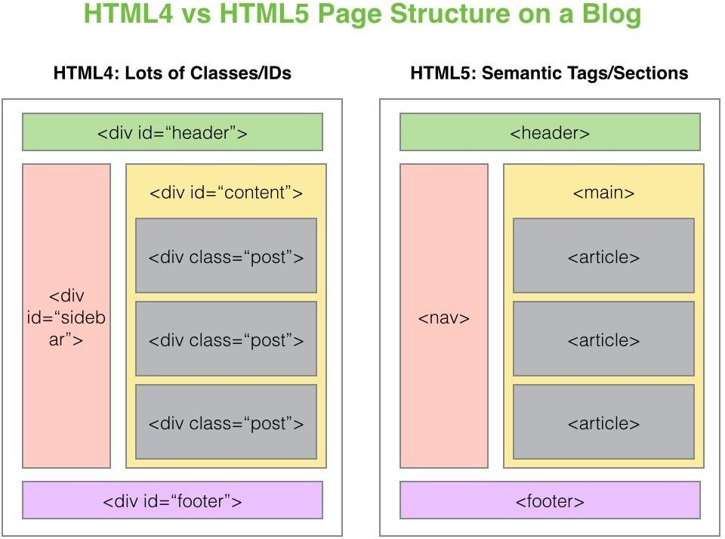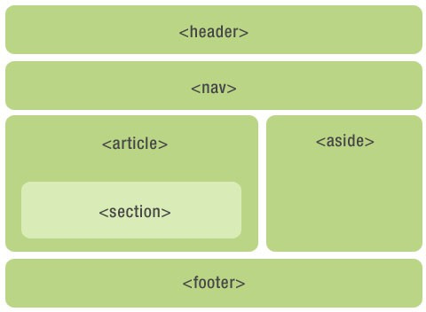

**Code and Output:**

# Create a static web page using HTML

<!DOCTYPE html>

<html>

<head>

<title>Basic HTML Page</title>

</head>

<body>

<!-- Header Section -->

<h1>Welcome to My Basic HTML Page</h1>

<!-- Navigation -->

<p>

<a href="#home">Home</a> |

<a href="#about">About</a> |

<a href="#services">Services</a> |

<a href="#contact">Contact</a>

</p>

<!-- Content Sections -->

<h2 id="home">Home</h2>

<p>This is a basic HTML webpage using standard tags without any styling or advanced features. It demonstrates the structure of a basic document.</p>

<h2 id="about">About</h2>

<p>My name is John Doe. I’m learning how to create webpages using simple HTML tags.</p>

<h2 id="services">Services</h2>

<ul>

<li>Website Development</li>

<li>Content Creation</li>

<li>Technical Support</li>

</ul>

<h2 id="contact">Contact</h2>

<p>You can reach me at:</p>

<p>Email: [example@example.com](mailto:example@example.com)</p>

<p>Phone: +123 456 7890</p>

<!-- Footer -->

<p>Thank you for visiting my website!</p>

</body>

</html>

# Output:

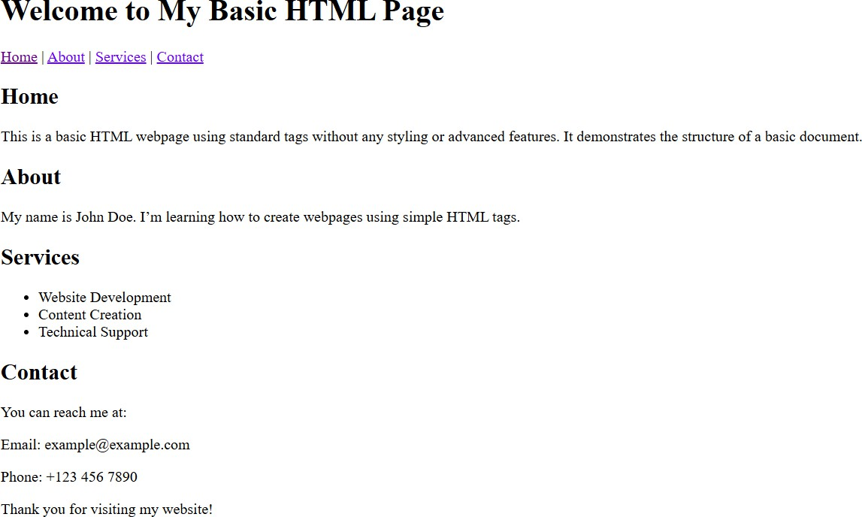

1. **Create a class timetable using HTML.**

<!DOCTYPE html>

<html>

<body>

<h1>TIME TABLE</h1>

<table border="5" cellspacing="0" align="center">

<!--<caption>Timetable</caption>-->

<tr>

<td align="center" height="50" width="100"><br>

<b>Day/Period</b></br>

</td>

<td align="center" height="50" width="100">

<b>I<br>9:30-10:20</b>

</td>

<td align="center" height="50" width="100">

<b>II<br>10:20-11:10</b>

</td>

<td align="center" height="50" width="100">

<b>III<br>11:10-12:00</b>

</td>

<td align="center" height="50" width="100">

<b>12:00-12:40</b>

</td>

<td align="center" height="50" width="100">

<b>IV<br>12:40-1:30</b>

</td>

<td align="center" height="50" width="100">

<b>V<br>1:30-2:20</b>

</td>

<td align="center" height="50" width="100">

<b>VI<br>2:20-3:10</b>

</td>

<td align="center" height="50" width="100">

<b>VII<br>3:10-4:00</b>

</tr>

<tr>

</td>

<td align="center" height="50">

<b>Monday</b></td>

<td align="center" height="50">Eng</td>

<td align="center" height="50">Mat</td>

<td align="center" height="50">Che</td>

<td rowspan="6" align="center" height="50">

<h2>L<br>U<br>N<br>C<br>H</h2>

</tr>

<tr>

</td>

<td colspan="3" align="center" height="50">LAB</td>

<td align="center" height="50">Phy</td>

<td align="center" height="50">

<b>Tuesday</b>

</td>

<td colspan="3" align="center" height="50">LAB

</tr>

<tr>

</td>

<td align="center" height="50">Eng</td>

<td align="center" height="50">Che</td>

<td align="center" height="50">Mat</td>

<td align="center" height="50">SPORTS</td>

<td align="center" height="50">

<b>Wednesday</b>

</td>

<td align="center" height="50">Mat</td>

<td align="center" height="50">phy</td>

<td align="center" height="50">Eng</td>

<td align="center" height="50">Che</td>

<td colspan="3" align="center" height="50">LIBRARY

</tr>

<tr>

</td>

<td align="center" height="50">

<b>Thursday</b>

</td>

<td align="center" height="50">Phy</td>

<td align="center" height="50">Eng</td>

<td align="center" height="50">Che</td>

<td colspan="3" align="center" height="50">LAB

</td>

</tr>

<tr>

<td align="center" height="50">Mat</td>

<td align="center" height="50">

<b>Friday</b>

</td>

<td colspan="3" align="center" height="50">LAB

</tr>

<tr>

</td>

<td align="center" height="50">Mat</td>

<td align="center" height="50">Che</td>

<td align="center" height="50">Eng</td>

<td align="center" height="50">Phy</td>

<td align="center" height="50">

<b>Saturday</b>

</td>

<td align="center" height="50">Eng</td>

<td align="center" height="50">Che</td>

<td align="center" height="50">Mat</td>

<td colspan="3" align="center" height="50">SEMINAR

</tr>

</table>

</body>

</html>

</td>

<td align="center" height="50">SPORTS</td>

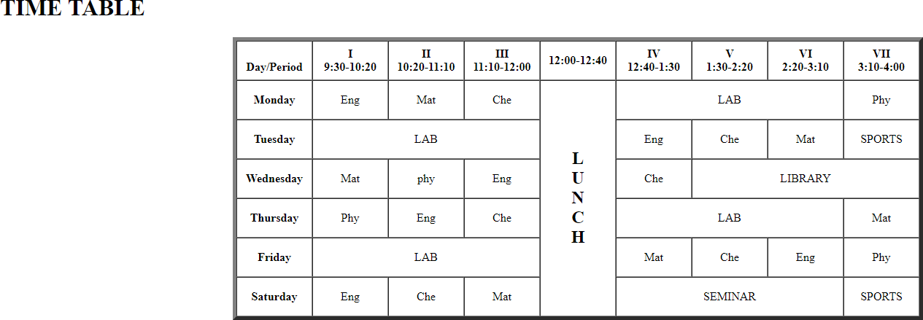

# Create a registration form using HTML.

<html>

<head>

<title> Registration Page

</title>

</head>

<body>

<br>

<br>

<form>

<label> Firstname </label>

<input type="text" name="firstname" size="15"/> <br> <br>

<label> Middlename: </label>

<input type="text" name="middlename" size="15"/> <br> <br>

<label> Lastname: </label>

<input type="text" name="lastname" size="15"/> <br> <br>

<label> Course :

</label>

<select>

<option value="Course">Course</option>

<option value="BCA">BCA</option>

<option value="BBA">BBA</option>

<option value="B.Tech">B.Tech</option>

<option value="MBA">MBA</option>

<option value="MCA">MCA</option>

<option value="M.Tech">M.Tech</option>

</select>

<br>

<br>

<label> Gender :

</label><br>

<input type="radio" name="male"/> Male <br>

<input type="radio" name="female"/> Female <br>

<input type="radio" name="other"/> Other

<br>

<br>

<label> Phone :

</label>

<input type="text" name="country code" value="+91" size="2"/>

<input type="text" name="phone" size="10"/> <br> <br> Address

<br>

<textarea cols="80" rows="5" value="address">

</textarea>

<br> <br> Email:

<input type="email" id="email" name="email"/> <br>

<br> <br> Password:

<input type="Password" id="pass" name="pass"> <br>

<br> <br>

Re-type password:

<input type="Password" id="repass" name="repass"> <br> <br>

<input type="button" value="Submit"/>

</form>

</body>

</html>

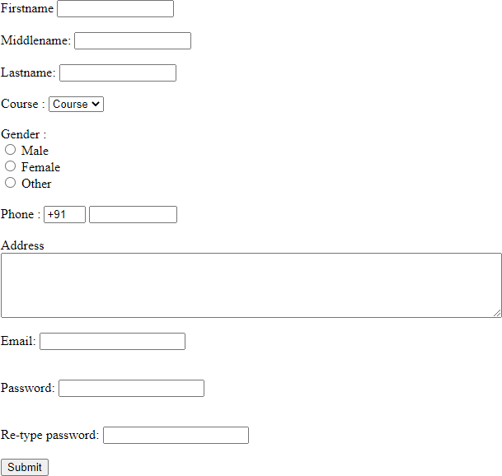

# Create a web page using HTML5 tags.

<!DOCTYPE html>

<html>

<head>

<title>

</title>

</head>

Simple Static Website

<body>

<nav class="navbar background">

<ul class="nav-list">

<li><a href="#web">Web Technology</a></li>

<li><a href="#program">C Programming</a></li>

<li><a href="#course">Courses</a></li>

</ul>

<div class="rightNav">

<input type="text" name="search" id="search">

<button class="btn btn-sm">Search</button>

</div>

</nav>

<section class="firstsection">

<div class="box-main">

<div class="firstHalf">

<h1 class="text-big" id="web"> Web Technology

</h1>

<p class="text-small">

HTML stands for HyperText Markup Language. It is used to design

web pages using a markup language. HTML is the combination of Hypertext and Markup language. Hypertext defines the link between the web pages. A markup language is used

to define the text document within tag which defines the structure of

web pages. HTML is a markup language that is used by the browser to manipulate text, images, and other content to display it in the required format.

</p>

</div>

</div>

</section>

<section class="secondsection">

<div class="box-main">

<div class="secondHalf">

<h1 class="text-big" id="program"> C Programming

</h1>

<p class="text-small">

C is a procedural programming language. It was initially developed by Dennis Ritchie as a system programming language to write operating system.

The main features of C language include low-level access to memory, simple set of keywords, and clean style, these features make C language suitable for

system programming like operating system or compiler development.

</p>

</div>

</div>

</section>

<section class="section">

<div class="paras">

<h1 class="sectionTag text-big">Java</h1>

<p class="sectionSubTag text-small"> Java has been one of the most popular programming language for many years. Java is Object Oriented. However it is not considered as pure object oriented as it provides support for primitive data types (like int, char, etc) The

Java codes are first compiled into byte code (machine independent code). Then the byte code is run on Java Virtual Machine (JVM) regardless of the underlying architecture.

</p>

</div>

</section>

<footer class="background">

<p class="text-footer">

Copyright ©-All rights are reserved

</p>

</footer>

</body>

</html>

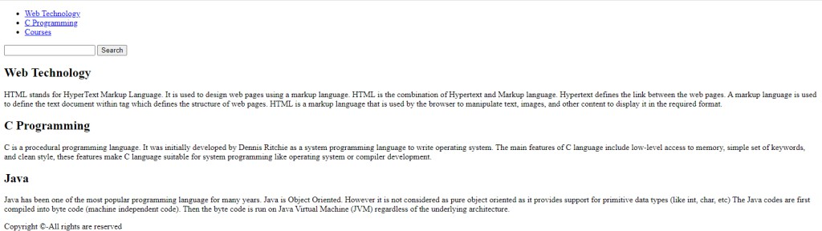

**Lab Assignments to complete:**

1. **Create a static page as the image posted below**

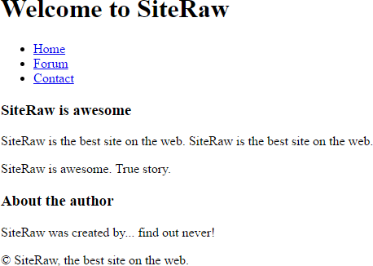

**CODE:**

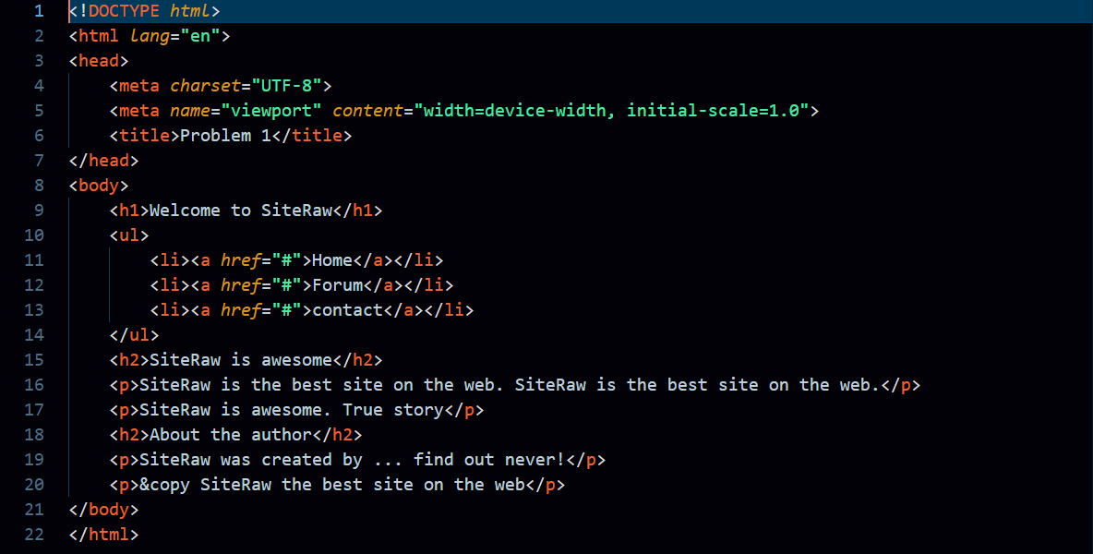

**OUTPUT:**

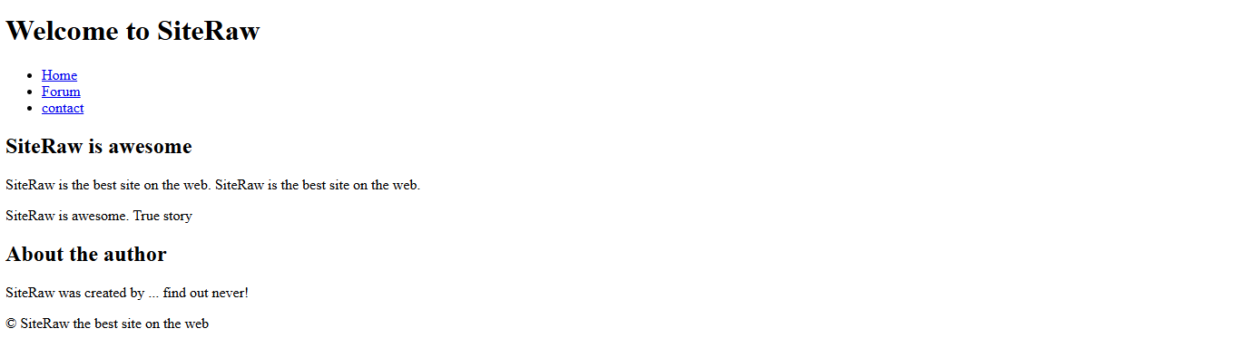

1. **Create the exact timetable of semester IV of your class.**

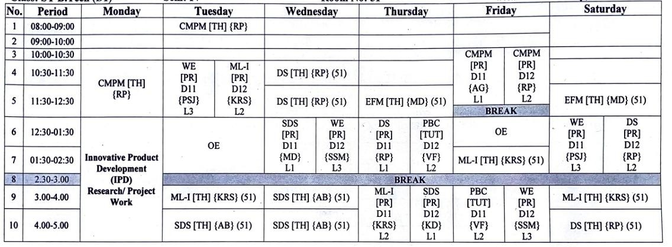

**CODE:**

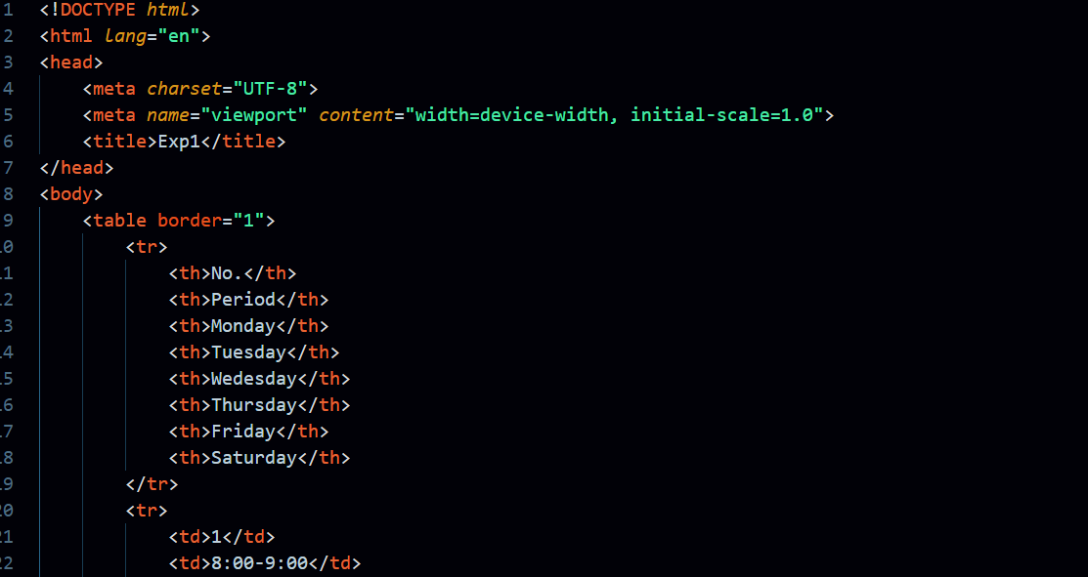 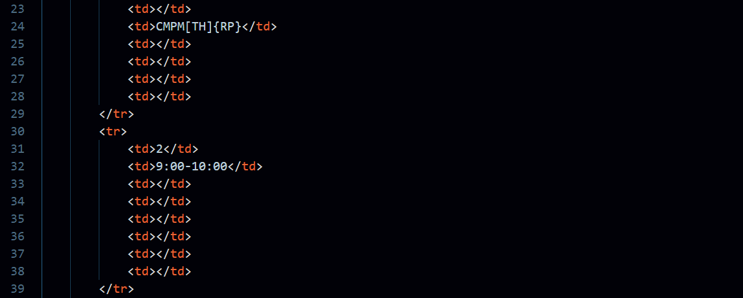 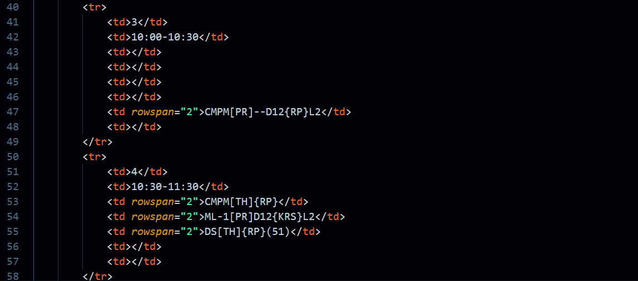 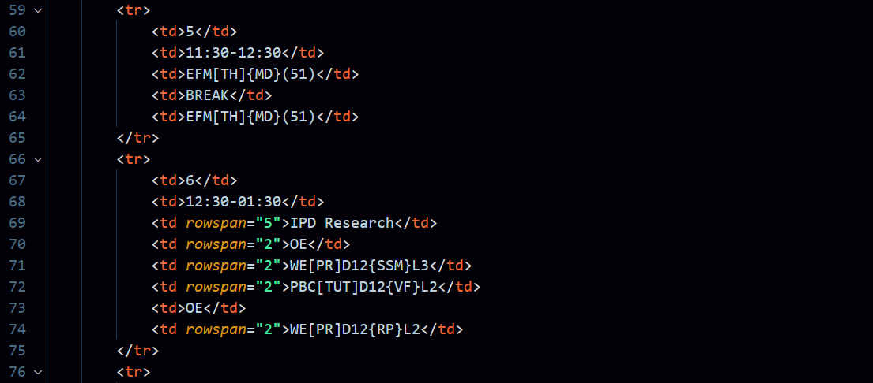 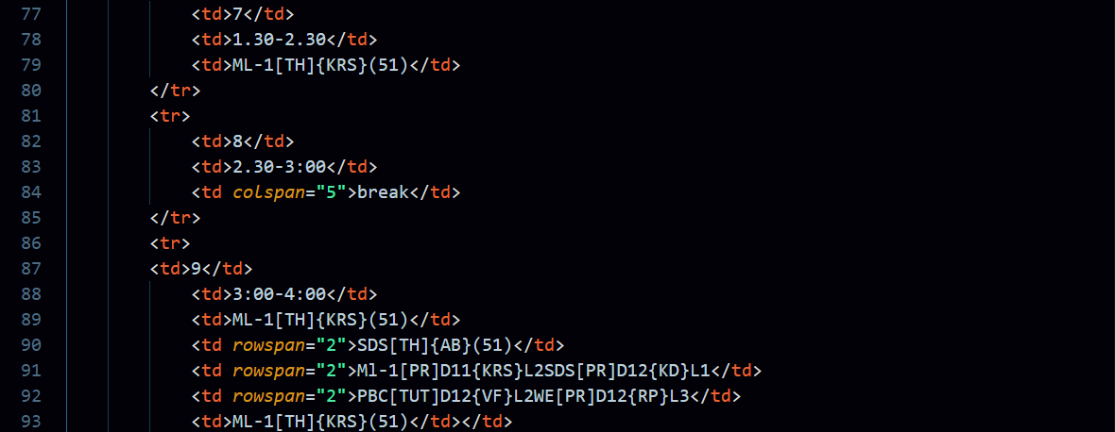 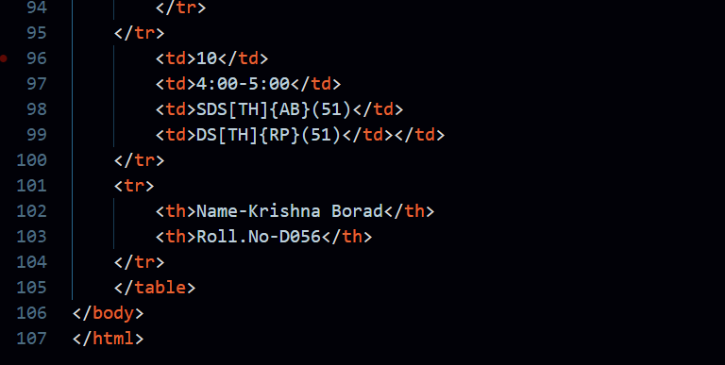

**OUTPUT:**

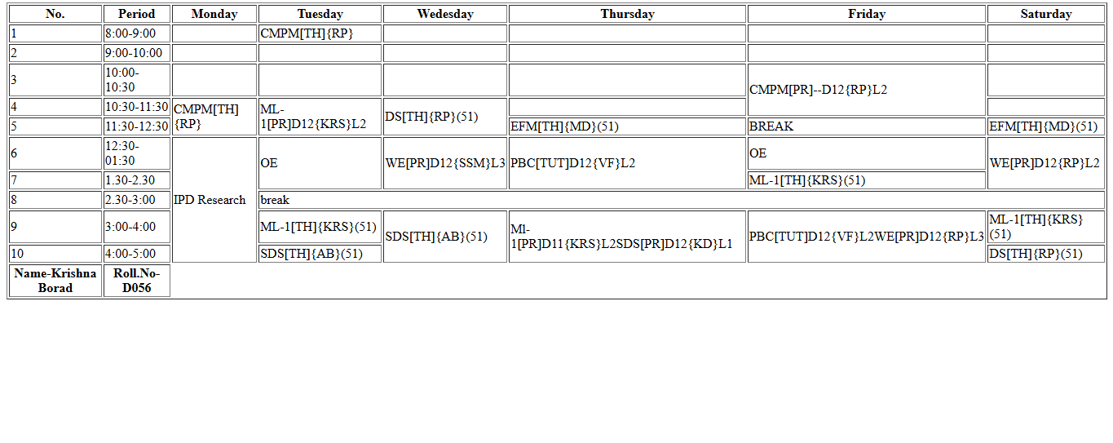

1. **Create a registration form using HTML as per the image shown below.**

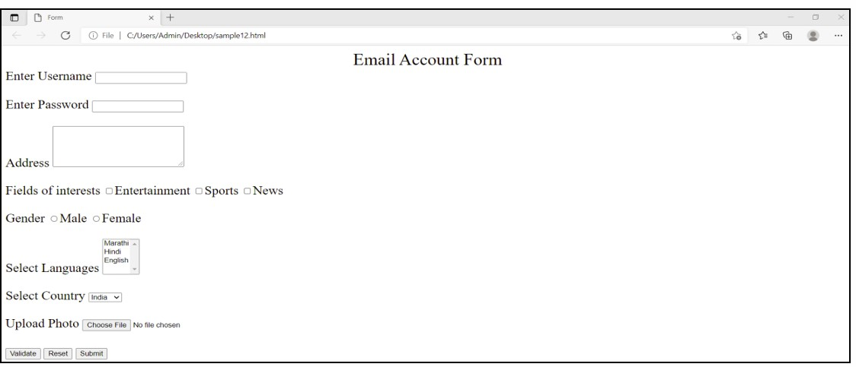

**CODE:**

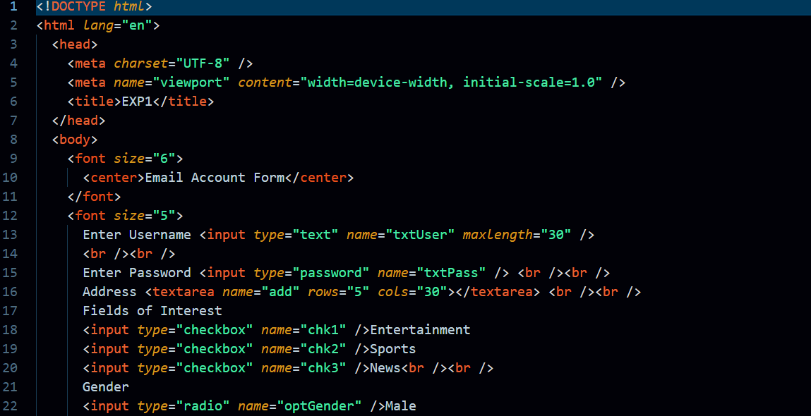 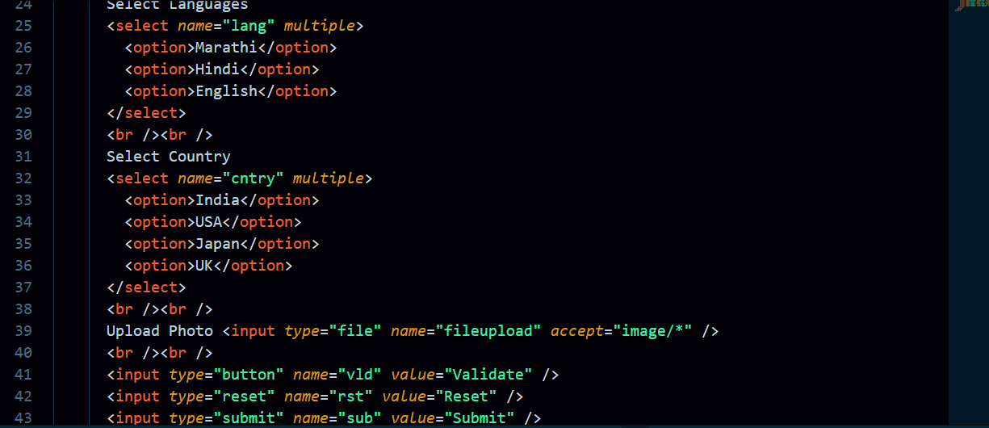 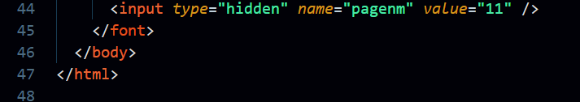

**OUTPUT:**

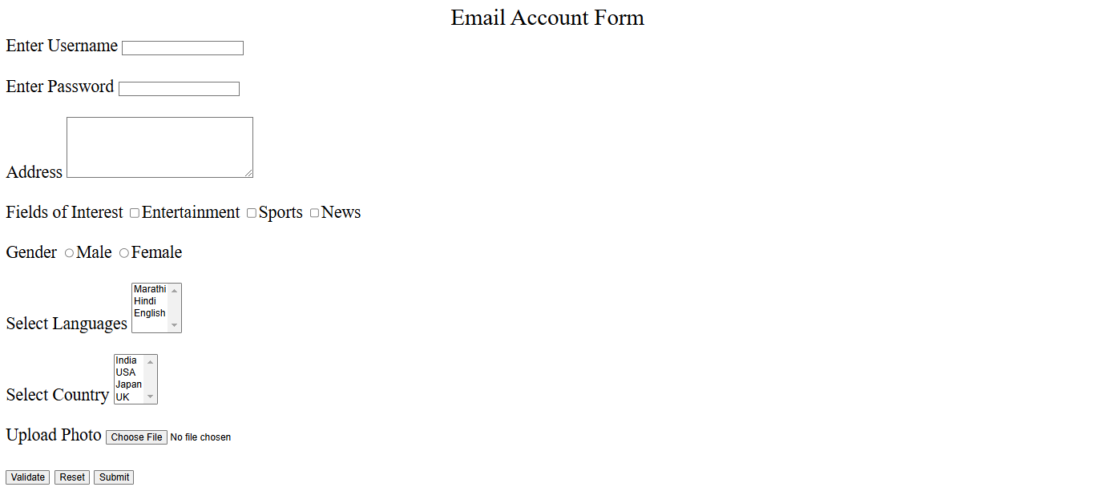

1. **Create a web page using HTML5 tags.**

**CODE:**

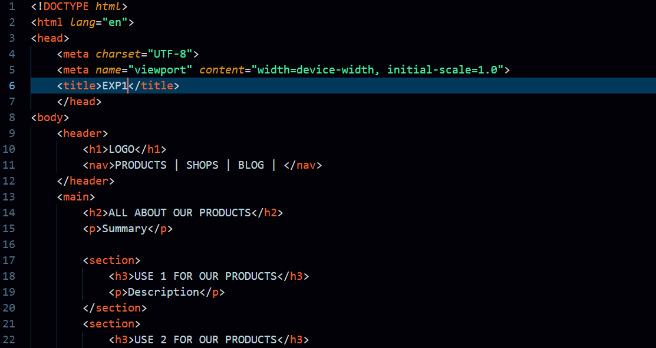 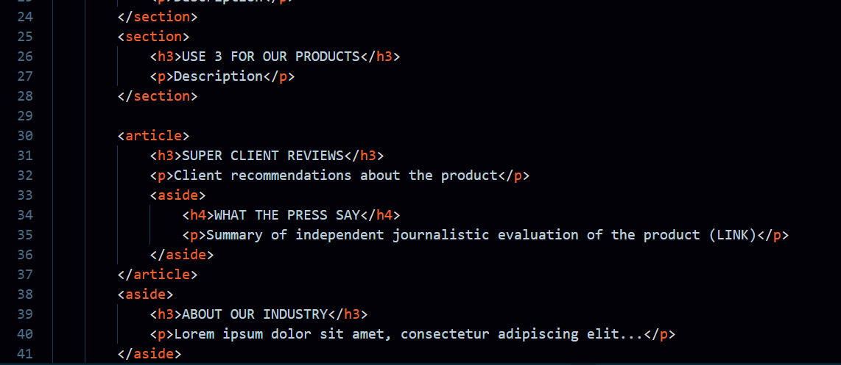 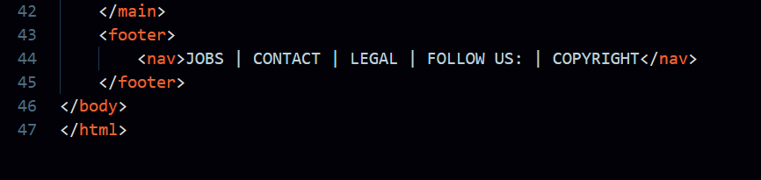

**OUTPUT:**

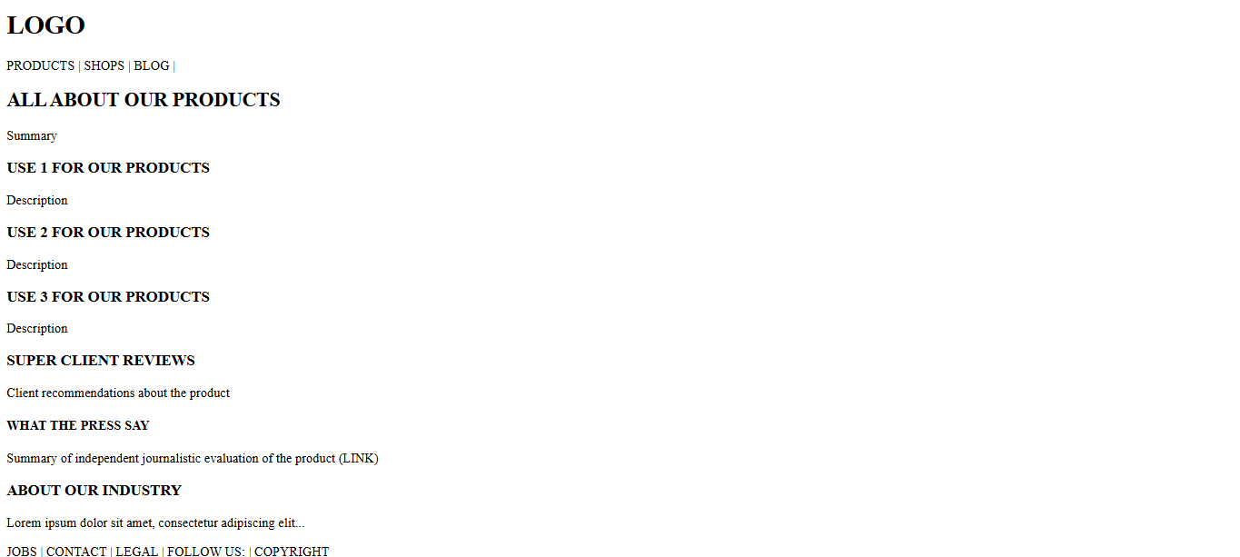

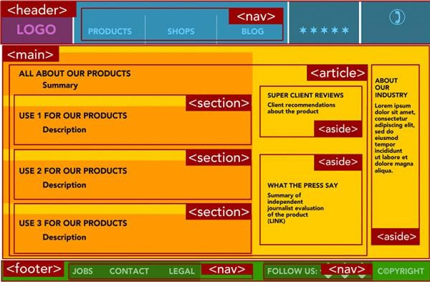

**Handwritten Theory:**

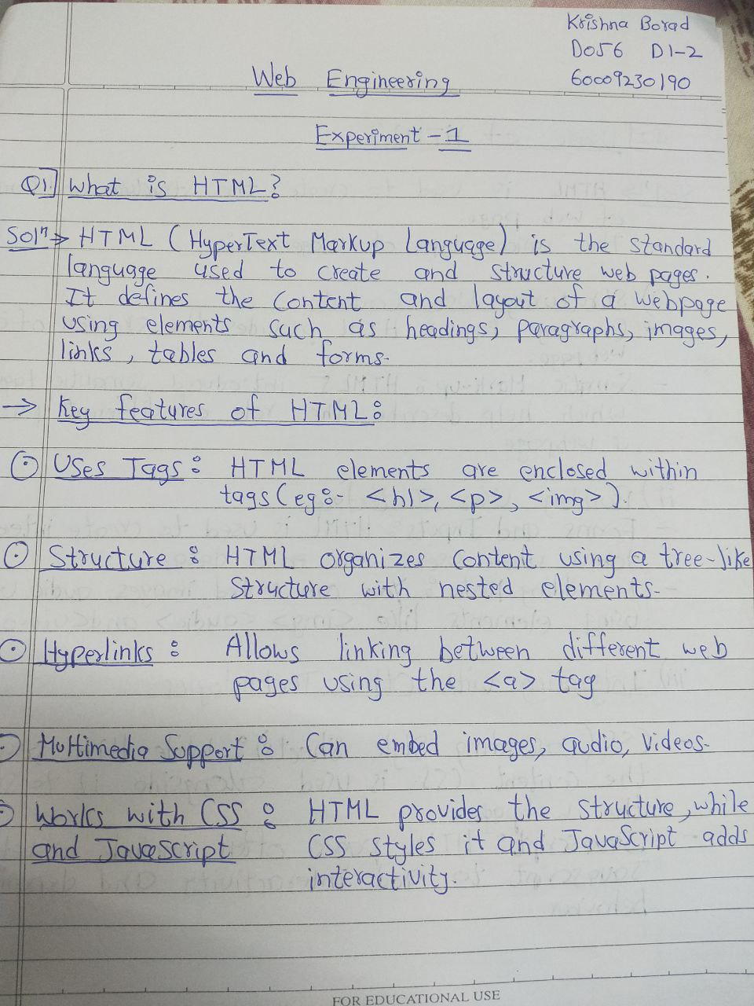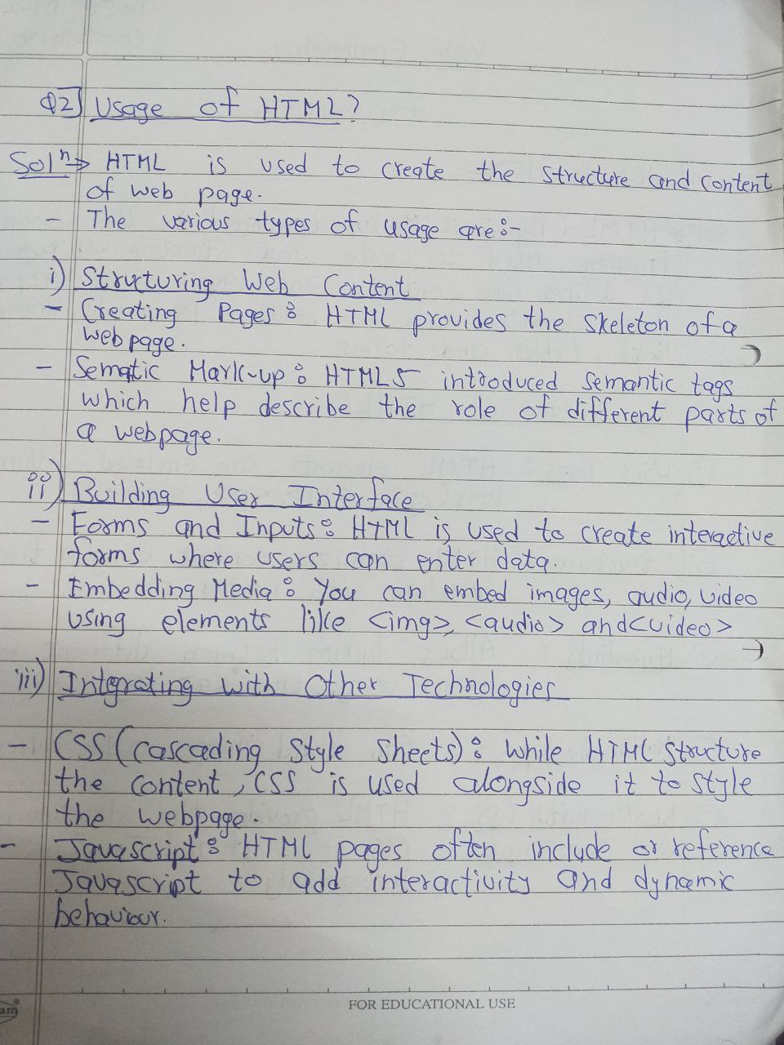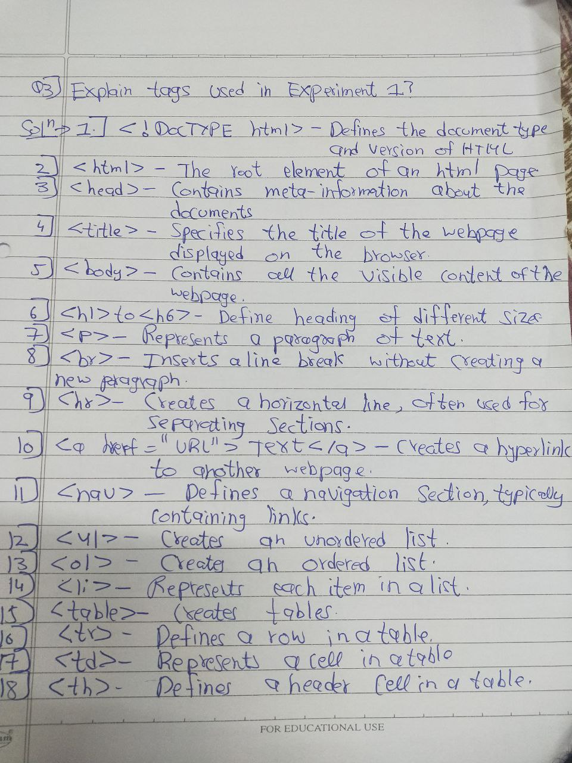

**CONCLUSION:**

The experiment aimed to implement basic HTML concepts by creating various static web pages. It involved designing a class timetable, a registration form, and a web page using HTML5 tags. Through this experiment, I gained hands-on experience in structuring web pages with tables, forms, and semantic elements. The practical application of HTML reinforced my understanding of web development fundamentals. Overall, this experiment provided a solid foundation for building structured and interactive web pages.